Senior Room: Children in 5th and 6th Class
Hi everyone,
Happy Monday! This Friday, 19th is Sports Day at Brannoxtown CNS! To prepare, we’ve planned a week which is mostly about… sport! There’s lots of great learning in this week’s Learning Guide. Our thanks go to Múinteoir Anne Marie who has collected fantastic resources for our week of sport.
- In the link above, check out the first column of Virtual Sports Day Ideas. Pick your two favourite activities and tell us about these at Wednesday’s Zoom.
- Every day this week, choose your favourite resource from the second column, Sports Activities and practise up to 30 minutes of sport. Come to our class zoom on Wednesday to tell us how you’re getting on so far with your Sports Activities.
- Now that sports leagues/training are resuming for some clubs, plan to share some updates about your favourite sports or teams with us at Wednesday’s Zoom.
- If you’re moving on to first year in September, check out your secondary school’s website to learn about the sports on offer.
You’ll find lots of links and resources in this Weekly Guide and on the last page to help you find information on your favourite clubs and teams. Have a super week!
Múinteoir Sarah
Monday, 15th June, 2020
6th Class: Transition Programme Zoom @11am
English & Social Studies: No Barriers at Home & SIF
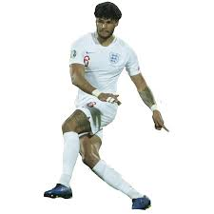 | The Greater London Authority, the Football Association of Ireland and the Mayor of London together created: No Barriers at Home, a fun project that brings people together, even when we can’t be together!  The project celebrates football ‘Champions’ from each of the 12 host cities of the UEFA EURO 2020 tournament who have overcome barriers to achieve success on the football pitch, including Stephanie Roche. Click on the ‘Big Ideas’ image to visit the Big Ideas site and:  - Watch the video to learn about an inspirational footballer who has tackled barriers to keep playing, fun facts about cities in Europe, and what this session’s #NoBarriersChallenge is.  - Read about them and where they’re from on your Champion Card and Host City Worksheet – click the icons to see that Champion’s page, then download them or scroll down to view them on the site.  - Fill in the activities and upload your work for a chance to be featured on our site! You can upload your work using the button below.
Unit 34, page 72 th | - Chant: Thick thumbs, thin thumbs, th, th, th.  - Action: Hold your thumbs apart for thick thumbs and close together for thin thumbs.  - Extra Graphemes: None!  - Tasks: 1, 3 & 4. Use your dictionary to check word meaning.
Maths: Problem Solving & Probability (Medal Muddle!)
Thirteen nations competed in a sports tournament. Unfortunately, we do not have the final medal table…

- Click on the image to read the pieces of information we have about how different countries scored.
- Try to re-create the medal table based on the information given.
Gaeilge: Cluiche Ceannais na nÉireann
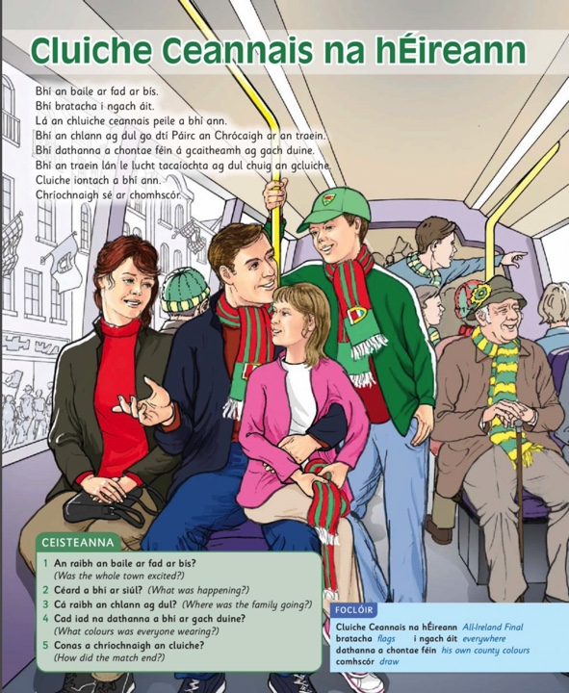  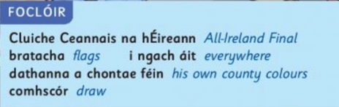 |  |  | - Today’s story is Cluiche Ceannais na hÉireann.  - Click on the image to open the page.  - Click this link to listen to the story read aloud.  - Léigh an foclóir gorm thíos/read the blue dictionary below.  - Léigh an scéal/read the story.  - Freagair na ceisteanna./Answer the questions.  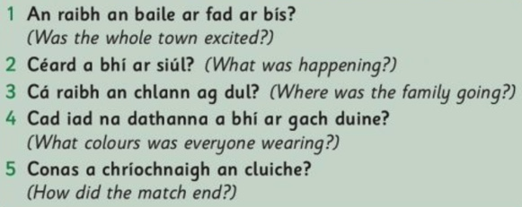

Tuesday, 16th June, 2020

English & PE: Defining Sport & SIF
Kiddle Sports Encyclopaedia | A sport is commonly defined as an athletic activity or skill and involves a degree of competition, such as baseball, soccer, bowling, or basketball. Some people like to watch other people play sports. Those who watch others playing sports are called fans. While some fans watch sports on television, others actually go to stadiums or other places where people pay to watch them in person. These fans are called spectators.  - Click on the robot image to access the Kiddle Encyclopaedia’s Sports page.  - Scroll down the page to learn about 4 sports that are new to you.  - Explain two of the sports by writing down five key facts about each.  - Share your writing with someone!
 | - Unit 34, page 72: th. Complete tasks 5 & 6.
Maths: Perimeter and Area
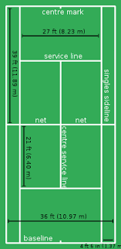  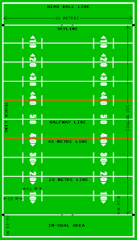 | - Find the perimeter and area of these sports pitches and courts below. All measurements are in metres (m):  - A Rugby Pitch: 68m wide, 100m long.  - A Football Pitch: 64m wide x 100m long.  - A Basketball Court: 15m wide, 28m long.  - A Tennis Court: 11m wide, 24m long.  - We use fractions to express one measure as a fraction of another measure. To show a tennis court’s perimeter as a fraction of a rugby pitch’s perimeter, we write our tennis court perimeter (numerator) over our rugby pitch perimeter (denominator) and then we simplify or reduce the fraction. To simplify, we ask which numbers are factors of both the numerator and denominator. We divide our fraction (numerator AND denominator) by one factor, then another factor and so on, until we can’t find any other factors to reduce our fraction.  - Show the perimeter of a Basketball Court as a fraction of a Football Pitch.  Remember:  Perimeter is the measure of the distance around a shape. We find perimeter by adding the sides of a shape. To measure perimeter, we use units of length like square metres.  Area is the measure of the surface covered by a 2-D shape. When we measure the inside of a flat shape, we are measuring its area. To measure perimeter, we use units of length like metres. We find the area of a rectangle by multiplying length by width.
Gaeilge: Tábla Sraithe
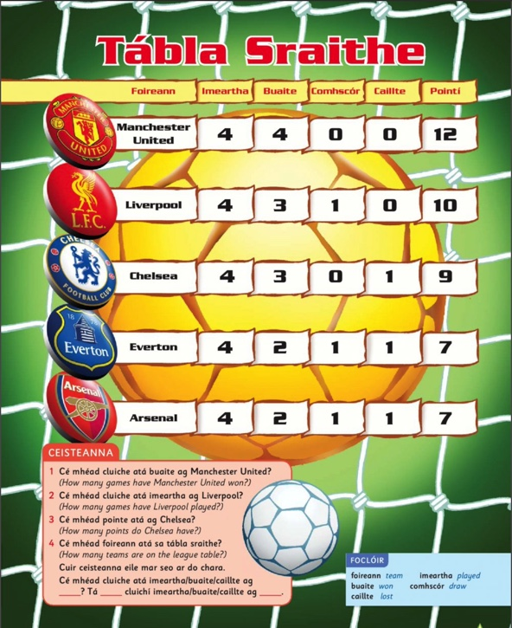  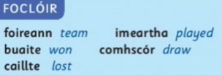 |  | - Today’s story is Tábla Sraithe.  - Click the story image to open the page.  - Click this link to listen to the story read aloud.  - Léigh an foclóir gorm thíos/read the blue dictionary below.  - Léigh an scéal/read the story.  - Freagair na ceisteanna./Answer the questions.  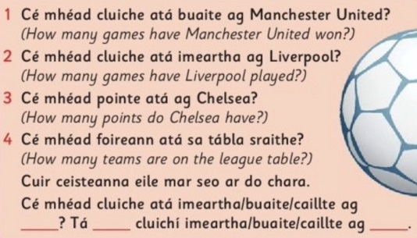

Wednesday, 17th June, 2020
Active Zoom session at 1:30pm & Class Zoom session at 2pm
English & Science
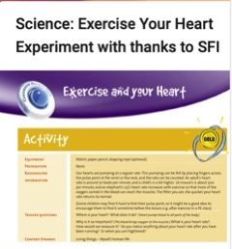 | Our hearts are pumping at a regular rate. This pumping can be felt by placing fingers across the pulse point at the wrist or the neck, and the rate can be counted. An adult’s heart rate is around 70 beats per minute, and a child’s is a bit higher. (A mouse’s is about 500 per minute, and an elephant’s 25!). Heart rate increases with exercise so that more of the  oxygen carried in the blood can reach the muscles. The fitter you are, the quicker your heart rate returns to normal.  - Click on the Discover Primary icon and follow the steps to check your heart-rate before and after exercise. Try to do this before our Zoom session on Wednesday and share your heartrate with the class!
Unit 34, page 73 th | - Chant: This feather, that feather, th, th, th.  - Action: Hold up a feather in your left hand for ‘this feather’ and another in your right hand for ‘that feather’.  - Extra Graphemes: the: breathe  - Tasks: 1, 3 & 4. Use your dictionary to check word meaning.
Maths: Angles
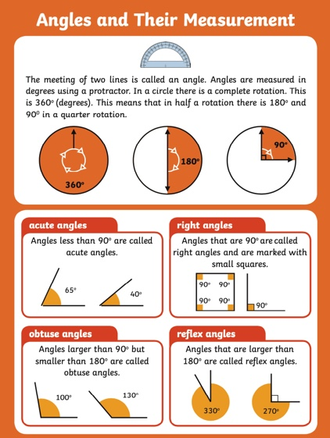 |  | - Click on the image to open a poster which summarises what we’ve learned about angles this year. Read through the poster slowly to revise what you know about angles.  - We used our protractor to measure angles in 2-D shapes. Use this transparent on-line protractor to measure angles in a picture or in any object around you, by taking a picture and uploading it, then dragging the midpoint of the protractor to the vertex (point) of the angle.  - Take this Angle Quiz to revise your knowledge of angles (ixl website).
 |  | Different sports involve angles in different ways. Gymnastics involves making the body twist, turn and spin to accomplish different feats. Hockey involves choosing the angle at which to pass the ball to another player or to aim for the goal. Using the Olympic Games as our focus, we can explore angles and turns.
Examine the 16 photos in the collection here (powerpoint) from nrich. Some photos have more than one angle.
- Explore your favourite photos. What angles you can see?
- Can you estimate them?
- Can you measure them for angles and turns?
- How do the athletes or players use angles to succeed in their sport?

 |  | Look at the icons on the Olympic website. Are there are any important angles in the pictures? Can you estimate them? Can you measure them?
Gaeilge: Cluiche a Chonaic mé le mo Dhaidí
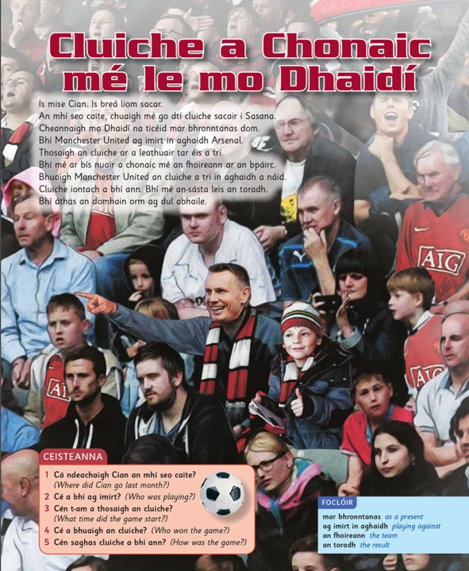  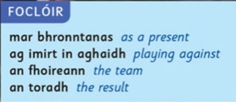 |  |  | - Today’s story is Cluiche a Chonaic mé le mo Dhaidí  - Click on the image to open the page.  - Click this link to listen to the story read aloud.  - Léigh an foclóir gorm thíos/read the blue dictionary below.  - Léigh an scéal/read the story.  - Freagair na ceisteanna./Answer the questions.  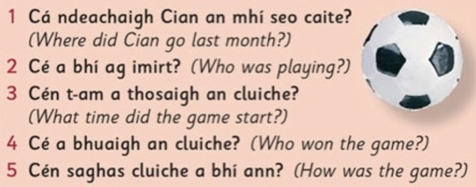

Thursday, 18th June, 2020
Olympic Games Day!
English & History: History of the First Olympics!
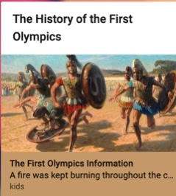 |  | Every four years, athletes from around the world gather to compete in events such as sprinting, long jump, discus, snowboarding, and figure skating as part of the Olympics. Their prize? Bragging rights for their home country—plus a shiny gold medal. Winners didn’t always get a medal, though. Victors in the earliest Olympics won a crown of olive leaves… according to the National Geographic site.
- Click on the picture to read about the history of the first Olympics.
- Write down what you believe are the 6 most important facts about the Olympics.
- Tell someone what you’ve learned about the Olympics!
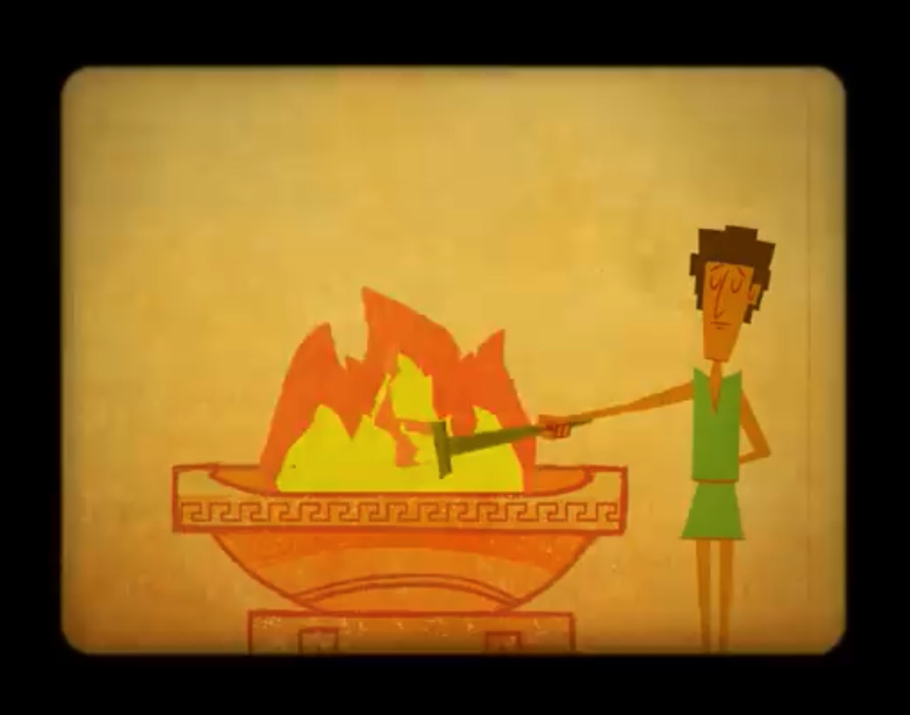 | Can you find any new facts about the Olympics in this video about the origins of the Olympic Games?  - Click on the video icon to learn about the ancient origins of… the Olympics!
 | - Unit 34, page 72: th. Complete tasks 5 & 6.
Maths: Measures, Data & Probability
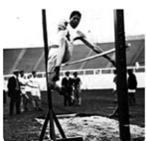 | How do YOU compare to results from Olympic Games in the past if you try similar running and jumping activities? This activity uses the history of the Olympic Games to introduce ideas about measuring time and distances in standard units.  - Click on the image to access the activity.  - Choose at least two sports to record your time and compare with the early Olympians!
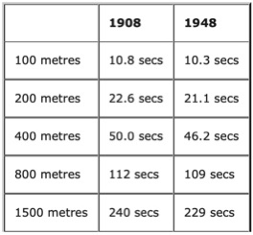 | Look at the changes in results on some of the athletics track events at the Olympic Games in 1908 and 1948.  - Click on the image to access the activity.  - What will the results be in 2012? This activity encourages you to examine data and consider different kinds of influencing factors.
Gaeilge: Na Cluichí Oilimpeacha
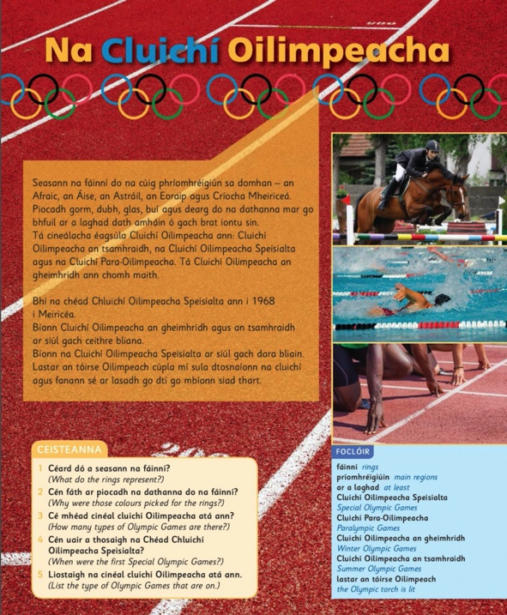  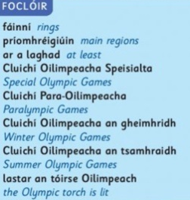 |  |  | - Today’s story is Na Cluichí Oilimpeacha.  - Click on the image to open the page.  - Click this link to listen to the story read aloud.  - Léigh an foclóir gorm thíos/read the blue dictionary below.  - Léigh an scéal/read the story.  - Freagair na ceisteanna./Answer the questions.  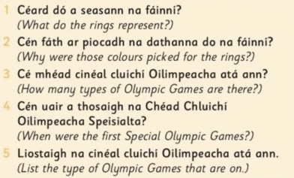

Friday, 19th June, 2020
Virtual Sports Day!
Some Sports Resources
Learn about some Irish, English, Scottish and Welsh Athletes who are helping children to learn about their sport and to stay active: https://www.sportsforschools.org/athletes/.

You’ll find everything you want to know about the GAA including the six different games in the family of Gaelic Games (Hurling, Gaelic football, Handball, Rounders, Camogie and Ladies Football) on the GAA site at: https://www.gaa.ie/the-gaa/games/our-games.

Information about club, provincial and Ireland Rugby is all available at: https://www.irishrugby.ie.

The Football Association of Ireland (FAI) site has lots of information on domestic (at home) fixtures (match schedules) here: https://www.fai.ie/domestic.

The American Library Association has collected a great set of websites for learning about different US sports: http://gws.ala.org/category/arts/sports.

Skysports.com/football, the Sky Sports News site, offers information on all the English leagues, including statistics, transfer information, newspaper gossip, television schedules, betting odds, expert predictions from former players, discussion forums and match score updates.

Premierleague.com, the Premier League site, gives fixture information, top news stories, score updates, links to Premier League club websites, statistics and podcasts.

Soccer-spain.com is a Spanish website that is devoted to the Spanish first and second divisions. Thankfully, it's written in English. The site has statistics, fixtures, ticket sales, transfer news, results and more.

If you’re interested in German football, check out the Bundesliga site for everything you want to know: http://www.bundesliga.de/en.

Mlssoccer.com has a similar format to the premier league site www.premierleague.com, but it is about the US Major League. Football is now the fastest growing team sport in the US.

The Italian Serie A site, Football-italia.net, is a good site for finding essential information about the Italian game.

You’ll find transfer information on the BBC website which summarises them on one page: http://news.bbc.co.uk/sport1/hi/football/gossip_and_transfers/default.stm.

