Senior Room: Children in 5th and 6th Class
Hi everyone,
I hope you had a super June Bank Holiday weekend! This Friday, June 5th, is World Environment Day. Our learning in English focuses on the world’s environment and what we can do as Global Citizens. Thanks to Irish Aid for providing lots of great resources.
Thanks for your feedback on the Weekly Learning Guide. You’ll see the same videos for Irish to give you more practice with stories about pastimes. Plan to write a story/scéal about your pastimes to share next week. In Maths, we’re revising Fractions this week and next. You suggested making videos to share; can you focus on fractions around you?
Be sure to keep up your fitness this week and remember you’ll find lots of ideas on our Active Padlet here. Practice your typing skills – just a few minutes of typing club a day will really improve your typing speed. I’m looking forward to hearing all your news at today’s zoom session at 2pm!
Sarah
Wednesday, 5th June, 2020
*Active Zoom session at 1:30pm* & *Class Zoom session at 2pm*
English & Social Studies
What does it mean to be a Global Citizen?
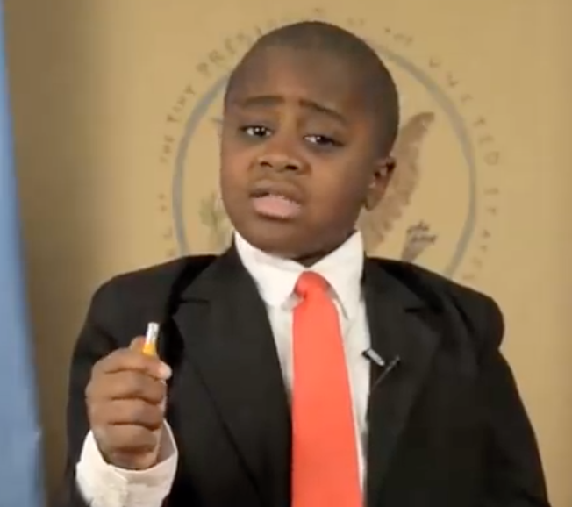 | - Meet Kid President who shares his ideas on How to Change the World. Click on the photo of Kid President to watch the short video.  - What are some of his ideas?  - Do you agree?
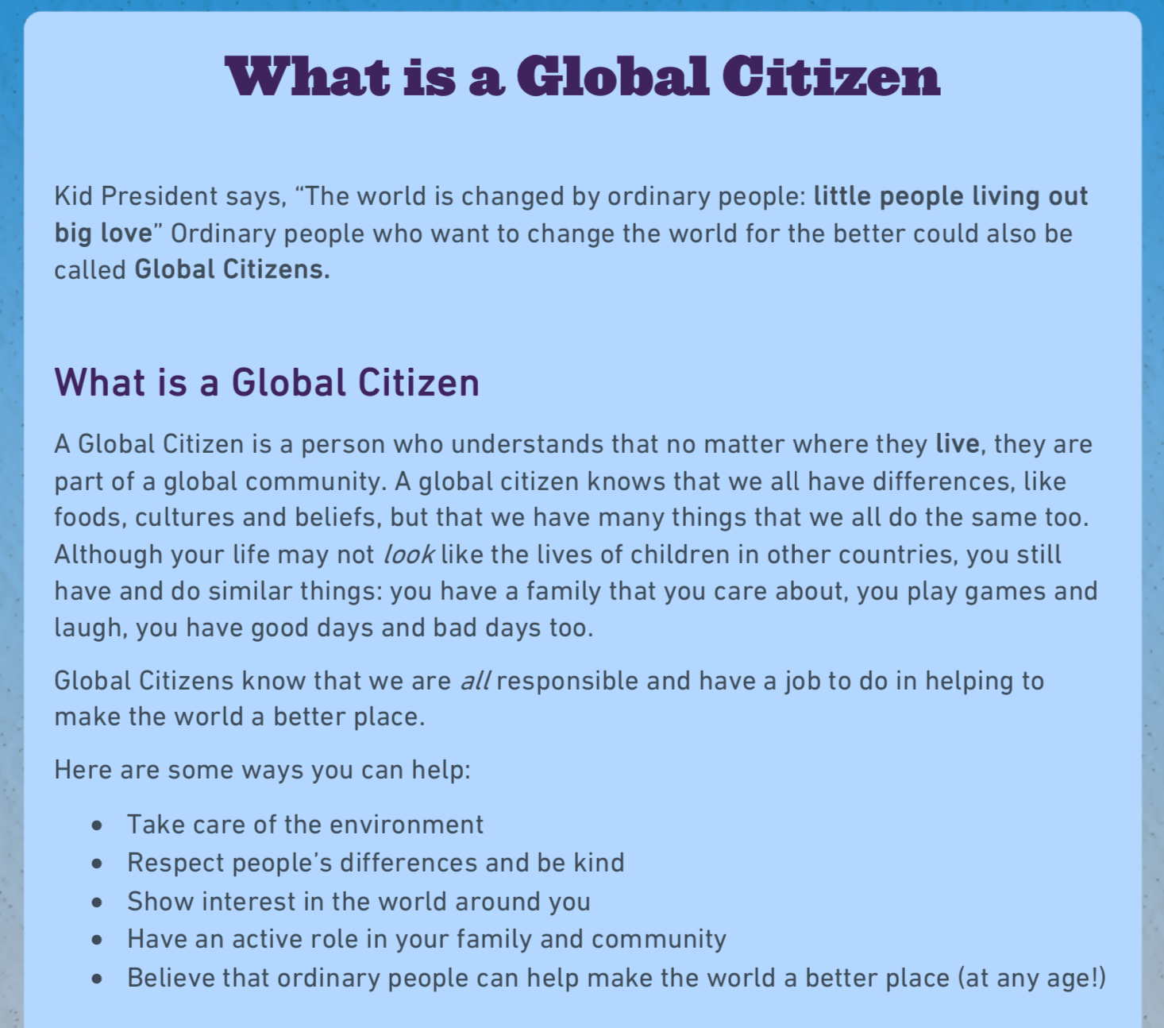 | - Kid President says, “The world is changed by ordinary people: little people living out big love” Ordinary people who want to change the world for the better could also be called Global Citizens. Click on the sheet to the left to read what it means to be a global citizen.
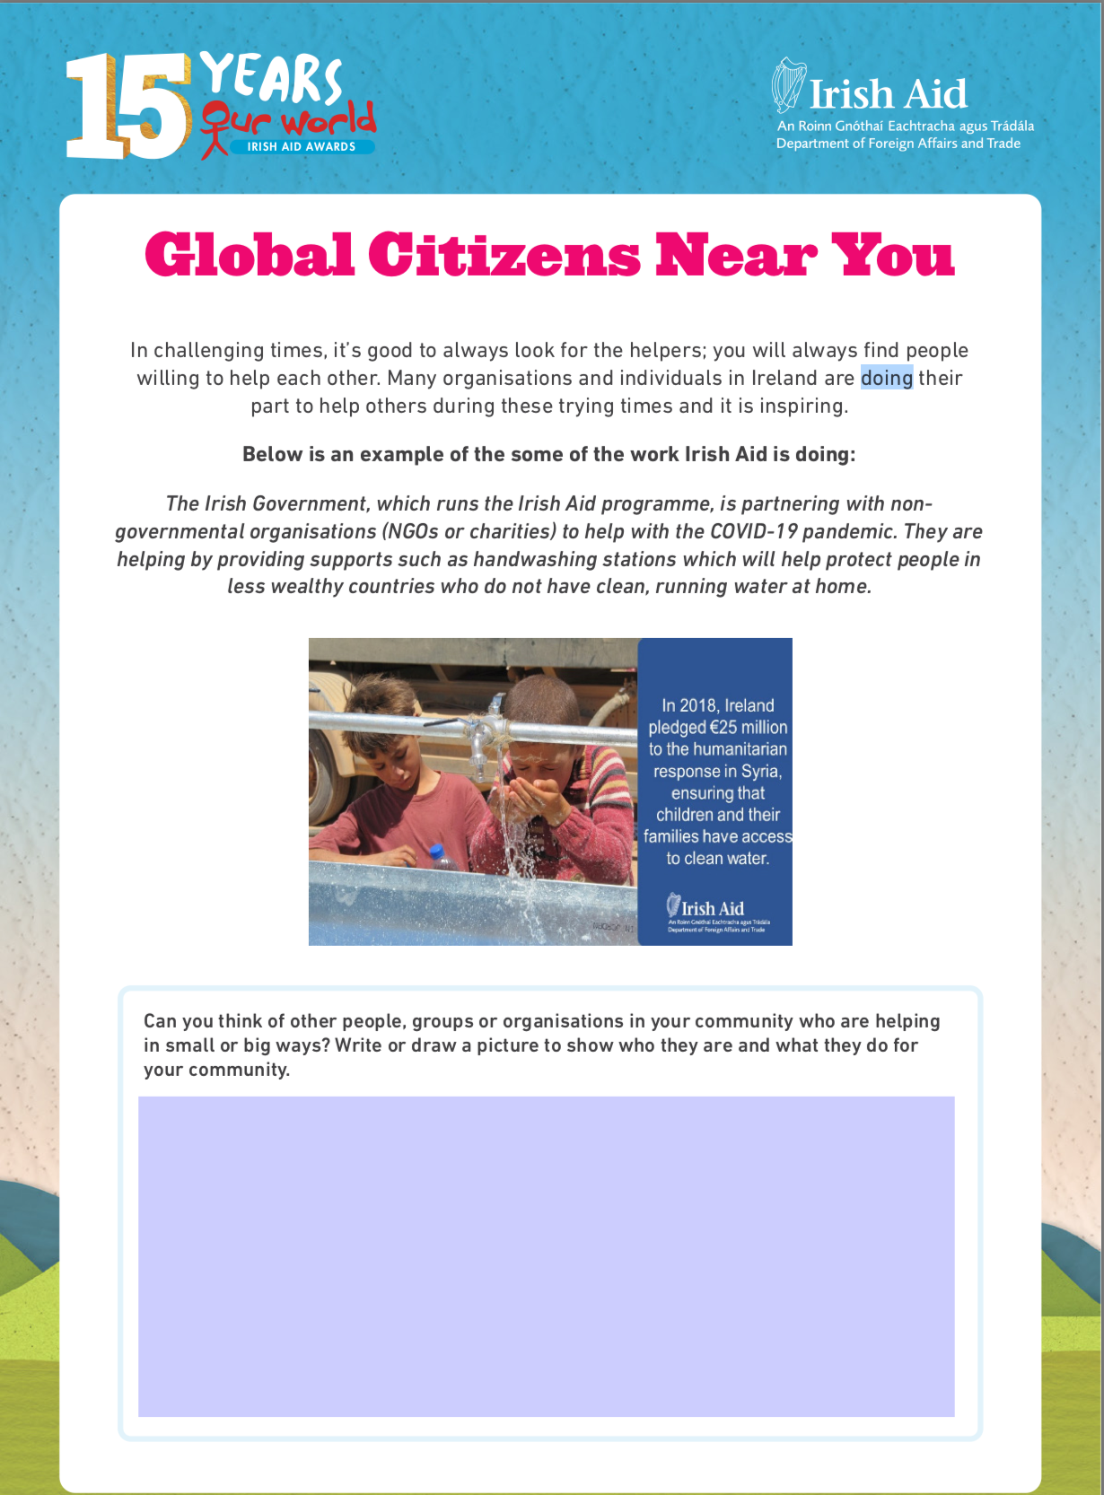 | - We can always find Global Citizens near us. These are people willing to help each other. You’ve heard lots of stories about local people doing their part to help others during the COVID-19 pandemic. Our Irish Government is also helping people in less wealthy countries by providing supports like handwashing stations to help protect people who do not have clean, running water at home.  - Can you think of other people, groups or organisations in your community who are helping in small or big ways? Write and draw a picture to show who they are and what they do for your community. Use your copy or click on the image on the left for the worksheet.
Unit 32, page 69 | - Chant: Shiny shell, sh, sh, sh.  - Action: Rub an imaginary shell in your hand.  - Extra Graphemes: s: surely, ss: tissue, xi: anxious and ssi: session.  - Tasks: 1, 2 & 3. Use your dictionary to check word meaning.
Maths: Finding a Fraction of an Amount
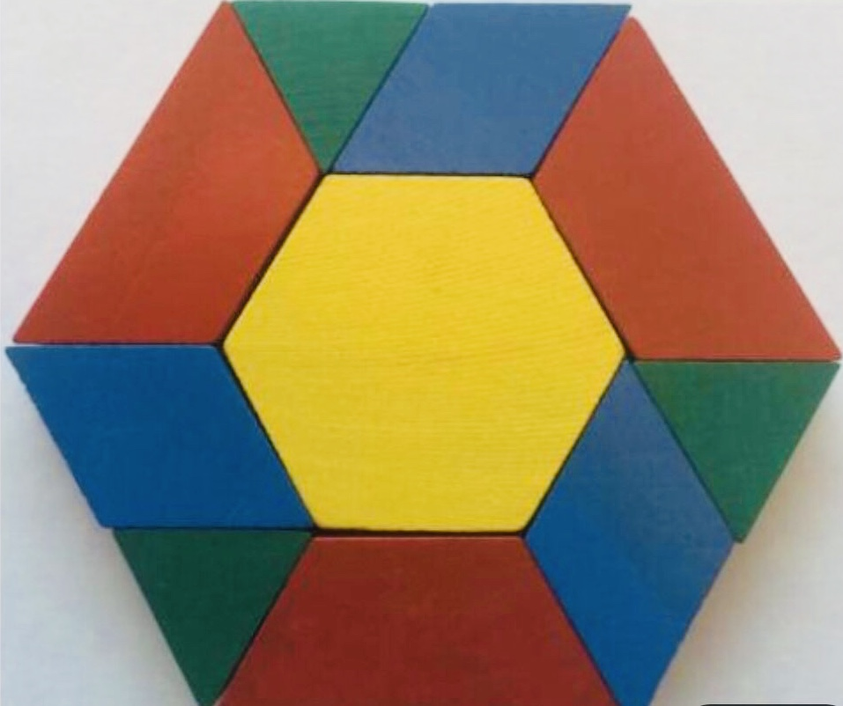 | - Click here to open a larger version of the image to the left. Look at the image with your maths eyes. What do you notice about this image? What shapes do you see? Do you see fractions? Let your math mind explore!  - We already know lots about Fractions. We know that:  - the numerator is the number of the top.  - the denominator is the number of the bottom (d is for denominator, d is for down).
- Take a look at this presentation to revise finding a fraction of a number.
- Read through the example of how to find a fraction of a number.
- Complete any 10 questions to show you can find a fraction of a number.
Gaeilge: Caitheamh Aimsire (Pastimes)
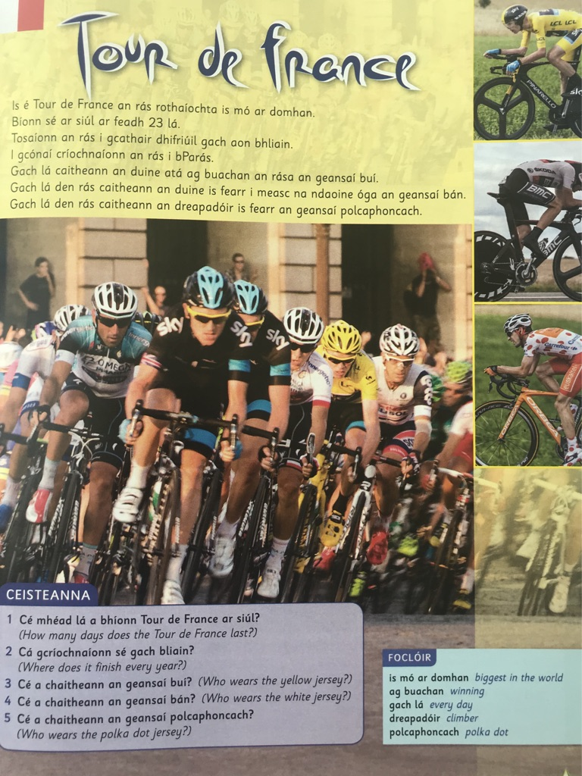 |  | - Click on the story to open the video.  - Eist leis an scéal. Listen to the story.  - Léigh an scéal. Read the story.  - Freagair na ceisteanna. Answer the questions.  - Practice the rap: Contae na Cúige Chonnacht. You’ll find the words here. The rap video is on the Class Dojo.  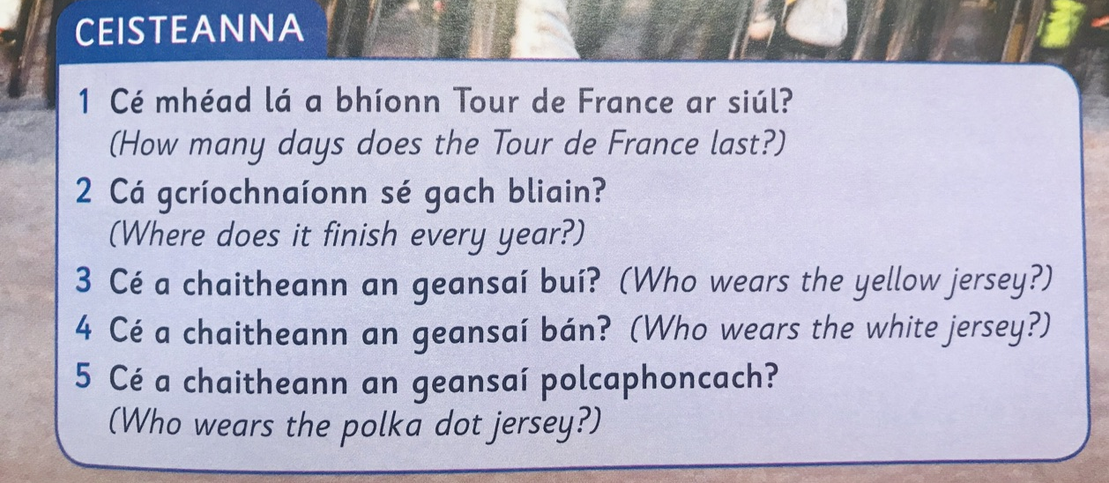
Buíochas le Joanne Kett & Eiile Ní Mhurchú (2018), Léigh sa Bhaile E, CJ Fallon.

Thursday, 6th June, 2020
Digital Detox Day
English & Social Studies
Global Citizens… Kids in Action!
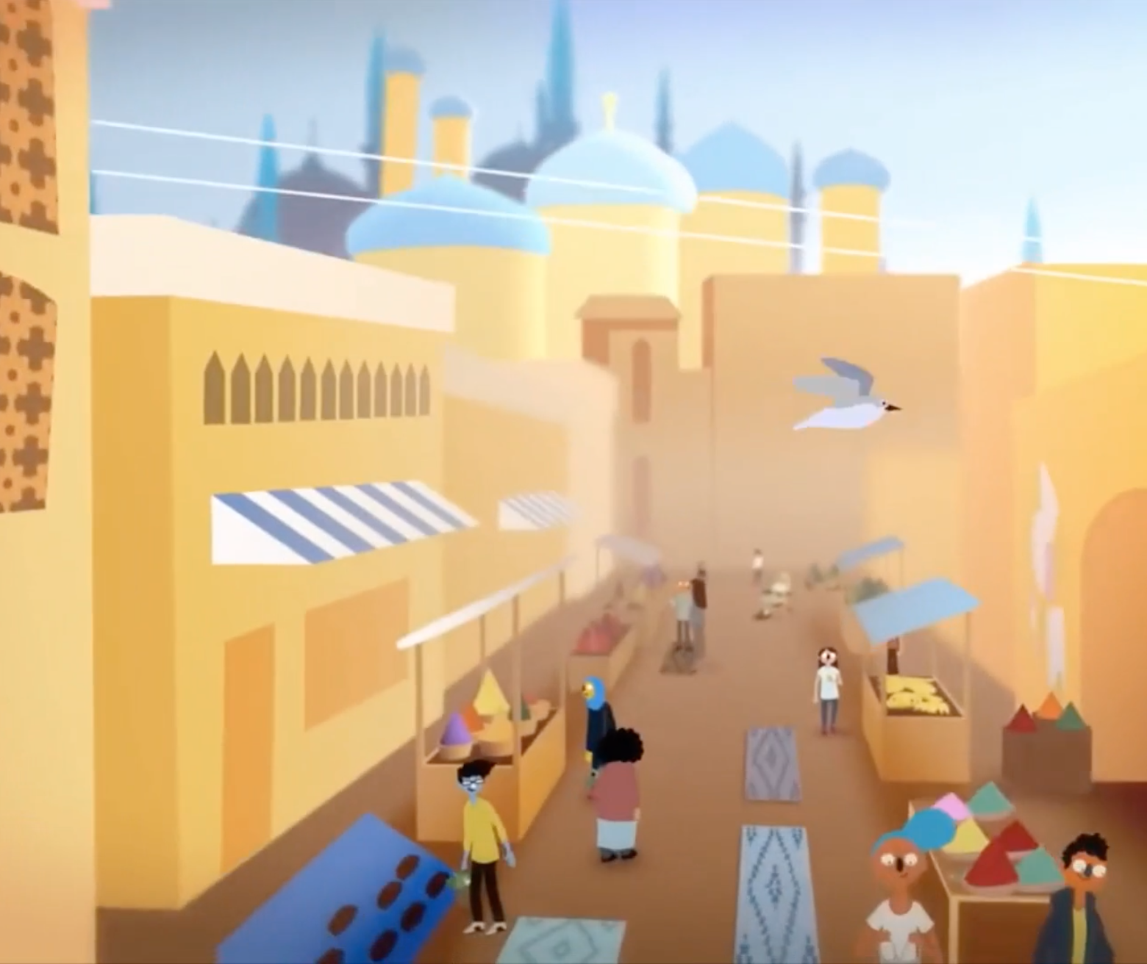 | - Click on the picture to watch a video about children who are active global citizens in their own countries/states: Turkey, Bali, India, Philadelphia, Nigeria and Jordan.  - What skills do we need to become global citizens? The video says the children who transformed their communities get creative and collaborate. Are any other skills needed?
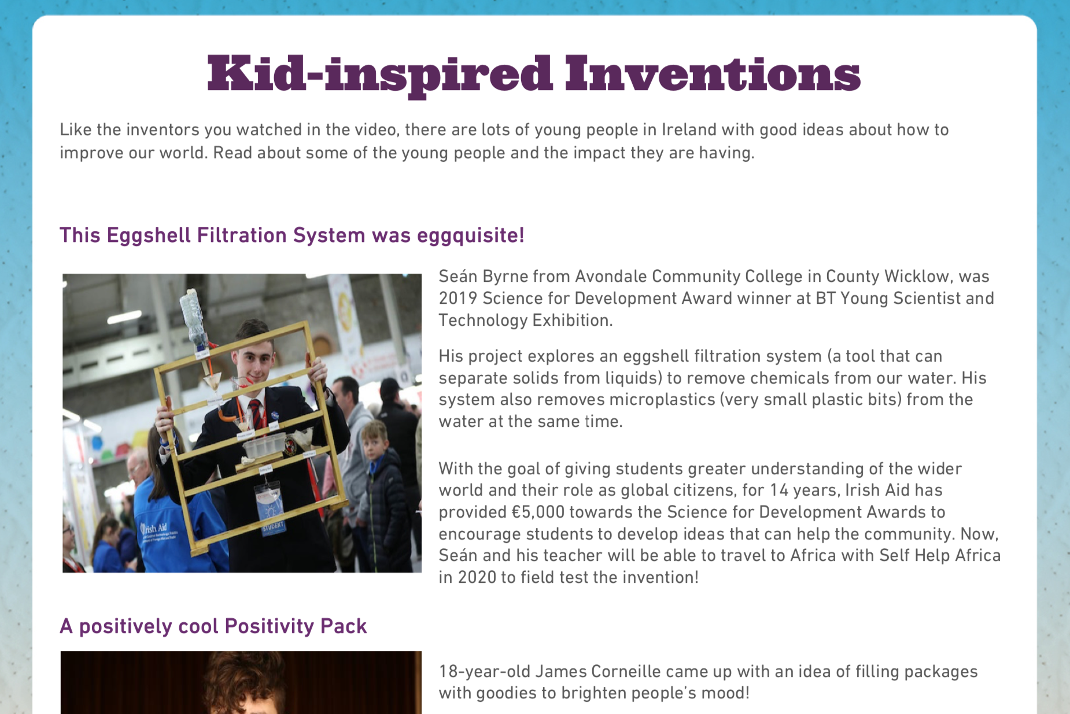 | - Like the inventors you watched in the video, there are lots of young people in Ireland with good ideas about how to improve our world. Click on the sheet to your left to read about some of the young people and how they are impacting our world for the better.
An Invention! | - Draw one of the inventions you just read about and include labels in your drawing or create your very own invention and explain what it is!
 | - Unit 32, page 69: sh, ch, ti, ci. Complete tasks 4 & 5.
Maths: Improper Fractions & Mixed Numbers
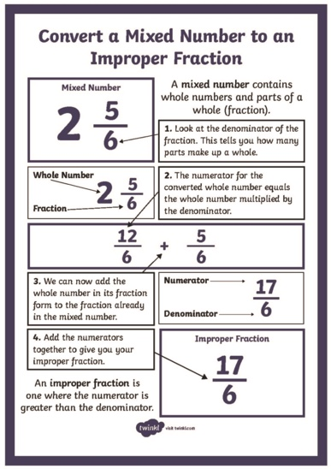 | - This year we learned about Improper Fractions and Mixed Numbers:  - An Improper Fraction is a top-heavy fraction. The numerator is greater than the denominator. Example: 5/4 (five quarters).  - A Mixed Number is a number that has a proper fraction and an whole number. Example 1 ¾ (one and three quarters).  - Click on the image to your left and read the steps to convert a mixed number to an improper fraction.  - Read the information on improper fractions and mixed numbers at the top of this image. Find the missing information on the number lines to show you can compare improper fractions and mixed numbers .
Gaeilge: Caitheamh Aimsire (Pastimes)
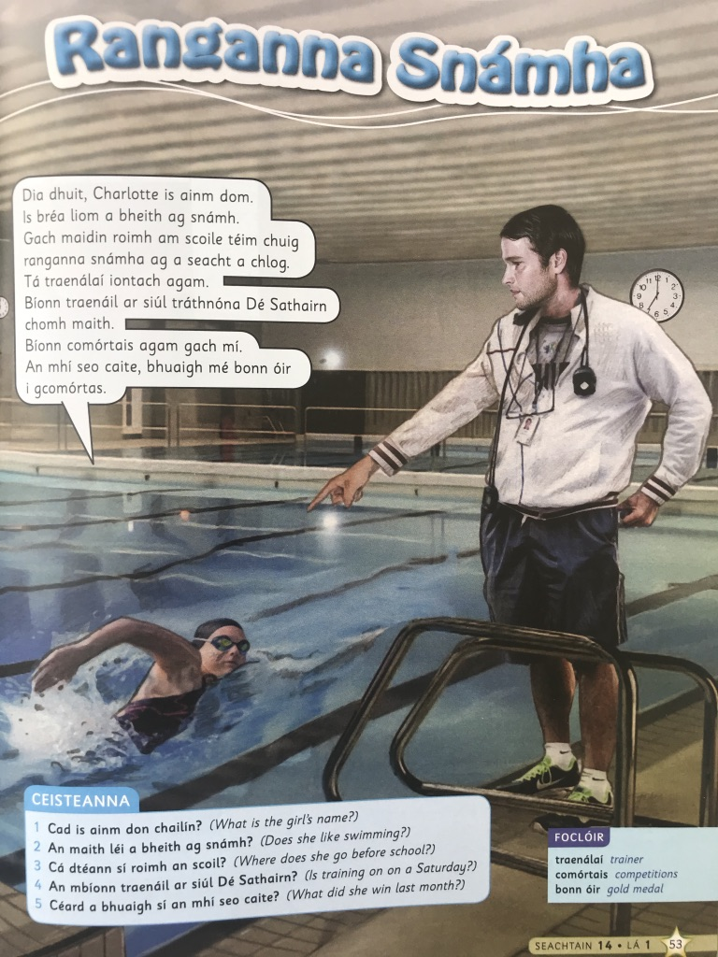 |  | - Click on the story to open the video.  - Eist leis an scéal. Listen to the story.  - Léigh an scéal. Read the story.  - Freagair na ceisteanna. Answer the questions.  - Practice the rap: Contae na Cúige Laighean. You’ll find the words here. The rap video is on the Class Dojo.  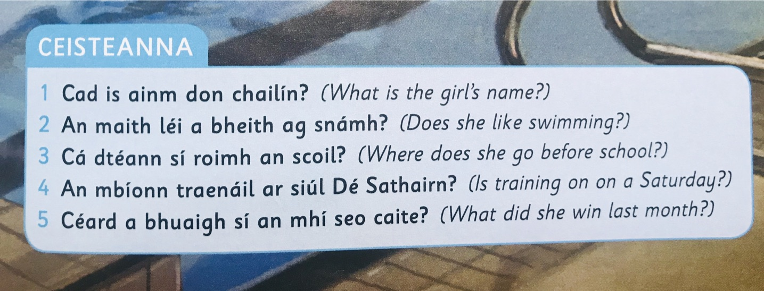
Buíochas le Joanne Kett & Eiile Ní Mhurchú (2018), Léigh sa Bhaile E, CJ Fallon.

Friday, 7th June, 2020
English & Social Studies
Global Goals
- Click the video link to the left to watch the World's Largest Lesson. Learn about the United Nation's 17 Sustainable Development Goals. As you watch, the video you will be prompted to answer some questions.
- When the video stops, take the quiz; click ‘Next’ to continue the video.
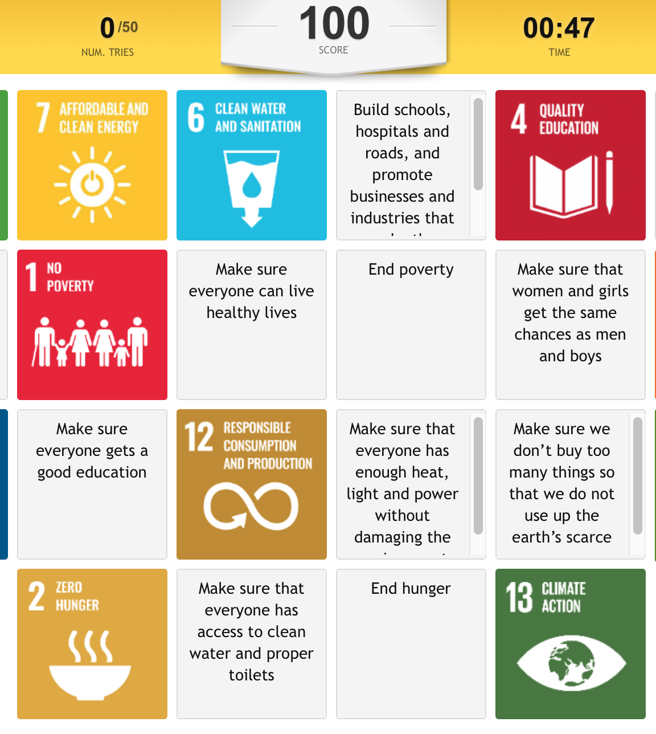 | - Test your knowledge and play a Global Goals Memory Game. To play the game, match each of the United Nation's Global Goals with their correct description. To Make a match simply click on a Global Goal Picture and then click the description you think it goes with. If it is a correct match it will flash and have a green outline! If there is no green outline try a different match combination. Let's get matching those Global Goals! (It is easier to play the game using ‘full screen’.  - Share your score with a family member or tell me how you got on by sending a message on the Class Dojo!
Share! | - Tell someone you know about the 17 Global Goals from the United Nations. Explain the goals you are most familiar with.
 | - Unit 32, page 69: sh, ch, ti, ci. Complete the Challenge Task.
Maths: Expressing one number as a fraction of another
- This week, we’ve been revising fractions. Take a look at this image which reminds us that we use fractions to express one number as a part of another. .
- Say which fraction is represented in each of the six images.
- Play this game to convert improper fractions to mixed numbers to fill as many customer orders as possible. This game will help you practice strategies for converting fractions!
- Play this Gem Mining game to convert proper and improper fractions.

Gaeilge: Caitheamh Aimsire (Pastimes)
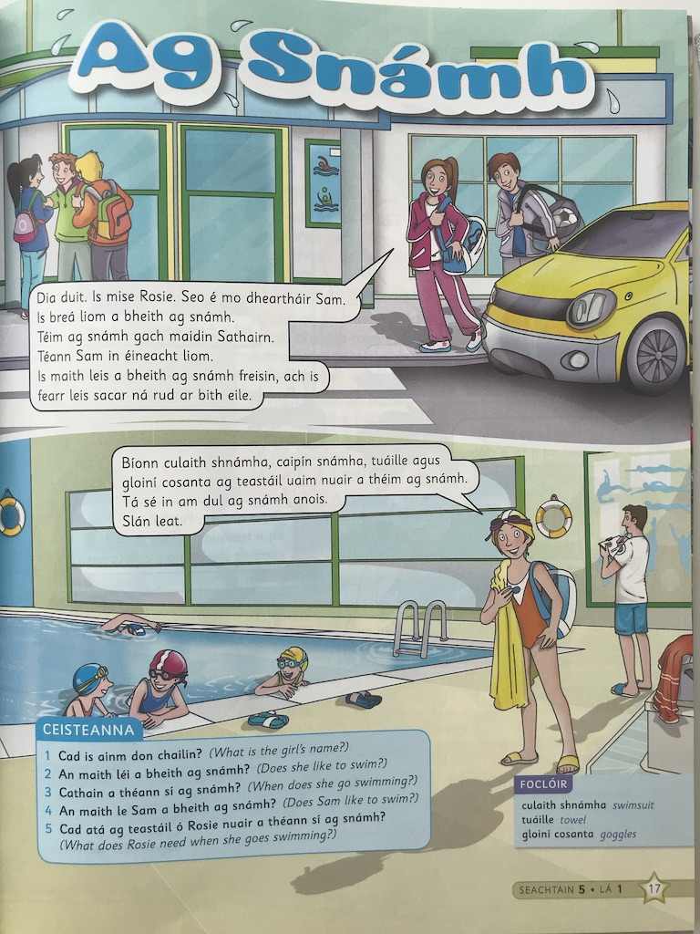 |  | - Click on the story to open the video.  - Eist leis an scéal. Listen to the story.  - Léigh an scéal. Read the story.  - Freagair na ceisteanna. Answer the questions.  - Practice the rap: Contae na Cúige Uladh. You’ll find the words here. The rap video is on the Class Dojo.  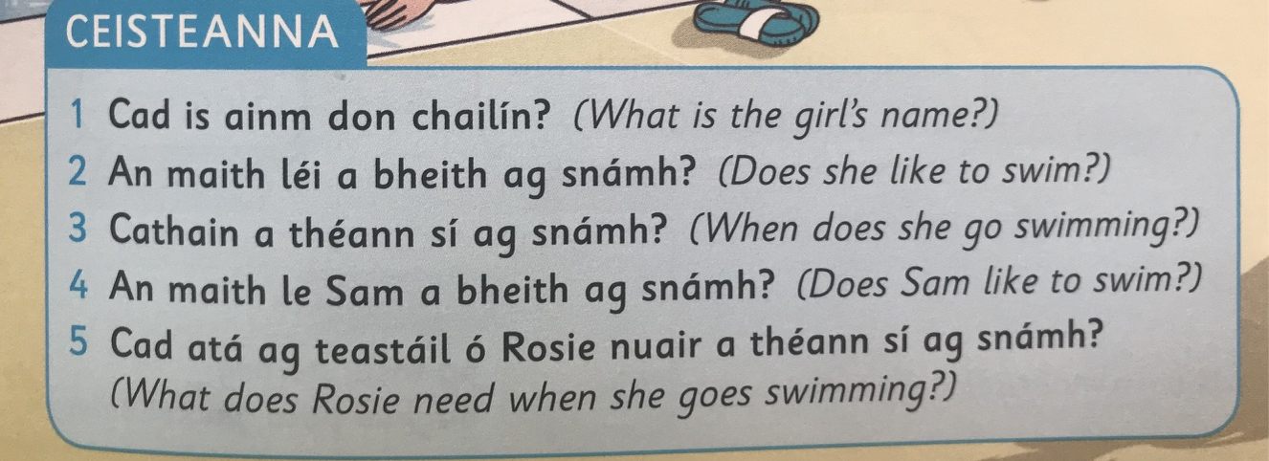

O’ Loughlin, N., (2009), Mathemagic 5, CJ Fallon, p. 38.
O’ Loughlin, N., (2009), Mathemagic 5, CJ Fallon, p. 39.
O’ Loughlin, N., (2009), Mathemagic 5, CJ Fallon, p. 41.

