Junior Room: Children in Junior and Senior Infants
Dear Parents,
This is our Learning Guide for the week. Children may not get to do everything and that’s ok. This week we are focusing on Active Home week so I have included activities for Active Home Week, English, Maths and Art.
On this sheet, the blue, underlined text is a hyperlink. It will take you to a web resource. Click it to go to the resource. If you have a question or you’re a little confused or you wish to share your child’s work, send me a message on the Class Dojo.
Happy learning!
Dawn

ACTIVE HOME WEEK:
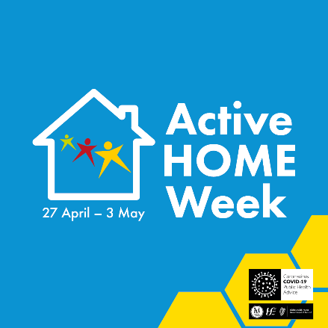

National “Active SCHOOL Week” takes place every April and is an enjoyable part of the school year for many children. This year, because of the school closure, it is not possible for this to go ahead so we are inviting the families in our school to take part in the “Active HOME Week” Challenge instead.

As part of Active HOME Week:
- We are inviting families to incorporate 60 minutes of physical activity into the day.
- We are encouraging children to find NEW ways of being physically active that they ENJOY.
- We are raising awareness about the fact that children need at least 60 minutes of physical activity every day.

To complete the challenge:
- Children are asked to find four different ways of being active every day (Monday to Sunday), making sure that they add up to 60 MINUTES.
- Children record their physical activity on the chart or draw a similar chart and send a picture via Class Dojo. A list of activities by day can also be sent via Class Dojo. Find a way to record activities that works for you at home and share with the class teacher!
- Take some photos of your physical activity ideas and share via Class Dojo for our Friday Facebook post and school website.

Further Information:
- Múinteoir Anne Marie will post a variety of links and challenges to “Class Story” on Class Dojo during the week.
- Active Flag have provided an Ideas Word Cloud and a Letter for Parents. Children are encouraged to create their own ideas too!
- This is the Challenge Chart to record activities. Múinteoir Anne Marie will upload a fillable PDF chart to Class Dojo.
- Check out the Active Flag Twitter feed (@activeflag). It includes lots of activities to suit children of all ages.

We are really excited about “Active HOME Week” and will be joining in at home too!

MATHS: Recognising Number
Number formation: Practise forming the follow numbers.
- Junior Infants: Number 5: Down and around and then you stop. You finish a 5 with a line on top.
- Senior Infants: Number 9. Make a loop and then a line, that’s the way we make a 9.
I have included a worksheet at the end of the document to for children to practise. They can use a range of colours to practise on the same sheet. Children can also form numbers using playdough or trace the number in sand.

Number recognition: We are focusing on the number 5 this week. Children can complete the following activities:
- Draw 5 items of clothing on a clothes line.
- Make sets of 5 using different objects e.g. lego bricks, teddies, toy cars etc.
- Count out 5 lollipop sticks (or any household item e.g. lego bricks, cubes etc). How many different ways can you add to 5? 1+4, 2+3 etc.
Senior Infants children are to complete the same tasks focusing on the number 9.
Active Home Week:
For Active HOME week, children can play the following maths based games:
- Hopscotch is a great game for number recognition and counting. Click here for a reminder of the how to play.
- What time is it Mr. Wolf? will encourage using time language (o’clock) and counting.

LANGUAGE: English
Reading
The picture book for this week is You Can’t Take an Elephant on a Bus.
Oral Language
- Help children to identify rhyming words in the story. Extend the learning by coming up with another rhyming word e.g. train, pain, rain etc.
- Children to practise ‘Row, Row your Boat’ and make up actions. The song is also attached at the end of the document. Encourage children to come up with their own verse for the song.
Writing
- Write your own: There are lots of different vehicles and animals in this book. Can you come up with your own example? I would love to see a dog riding a bike!
Active HOME week: Children can draw a picture and write words/sentences about the different activities they complete each day.

Phonics and Sight Words
Below I have included active games that you can use to practise different sounds and sight words:
- Bowling: If you have plastic bowling pins at home, attach different sounds/sight words to the bowling pins. When your child hits a pin, they say the sound/word. If you don’t have a bowling set, you can improvise with a soft ball and teddies, toys etc.
- Hopscotch: Play a traditional game of hopscotch using sounds or sight words instead of numbers.
- Word Hunt: Hide different sight words around the house or garden. Children can collect and read the words.
- Jump and read CVC words: Use three hula hoops or draw three circles using chalk. Write a different letter in each circle. Children jump into each circle and say the sound. At the end, they blend the word e.g. p-i-n, PIN.

pin
P I N

LANGUAGE – Gaeilge
- Bua na Cainte (the digital resource we use in school) can be accessed online and installed on PC/Mac for free as a result of the school closures. Click here for access. Select Junior Infants/Senior Infants when prompted. Username: trial Password: trial. Try to download it this week if you can. We are continuing to work on the unit “Éadaí” (Clothes) this week. Children can explore the songs, rhymes, games and story in this section. Let me know how you are finding Bua na Cainte and if I can help.
- Cúla4 has lots of familiar cartoons and games in Irish.

ARTS EDUCATION
- Nature Creation: Children can use resources they find outside, e.g. twigs, leaves, stones, to create some nature art. I have include some examples. I would love to see what you create!
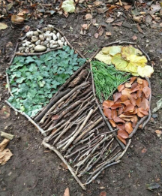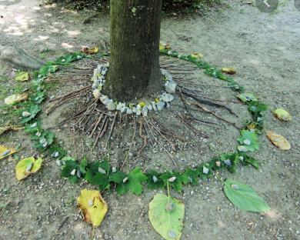
WELLBEING:
Choose from any of the following activities:
- Go Noodle family access.
- Joe Wicks, The Body Coach is covering PE at home this week on his You Tube channel. Videos are live at 9am but also save to the channel for later use.
- Active Homework Ideas
- 10@10
- Cosmic Yoga

PLAY:
Choose from different activities.
- Fine motor: jigsaw puzzles, lego, threading, colouring, cutting and sticking, playdough etc.
- Free Play: Children choose their own activities.
- Exercise/Outside Play: Activities outlined in the Wellbeing section can also be used here.
- Construction: Lego, bricks, etc. As our topic is transport, children can focus their construction on transport e.g. build a car, bridge etc.
- Water Play: Set up water play inside or outside using a large container and different objects e.g. plastic containers, plastic toys, sieve, wooden spoon etc.

