Junior Room: Children in Junior and Senior Infants
Dear Parents,
This is our Learning Guide for the week. Children may not get to do everything and that’s ok. When we’re in school, we have scheduled time each day for Maths English and Irish and three other curriculum areas: Arts (Visual arts, Drama and Music), SESE (History, Geography and Science) and Wellbeing (PE, Social Personal and Health Education and Goodness Me, Goodness You). While you’re at home, you might try some activities in Maths, English and Irish each day and dip in to the other subjects as children wish.
On this sheet, the blue, underlined text is a hyperlink. It will take you to a web resource. Click it to go to the resource. If you have a question or you’re a little confused or you wish to share your child’s work, send me a message on the Class Dojo.
Our topic for April is ‘Transport’. Different aspects of transport are integrated into our learning for April.
Happy learning!
Dawn

MATHS: Counting and 3D shapes
- Below are two counting worksheets. If you choose to print them, I would encourage printing them in the black and white version so that children can also colour the sheets if they wish. Children can also cut out the vehicles, sort them, create a collage or use them to combine numbers.
  - Transport- I Spy and Count to 10
  - Transport I Spy and Count to 20
- Shape: most forms of transport have wheels. Children can investigate different 3D shapes at home to investigate which 3D shapes can roll e.g. cans, books, cereal boxes etc.
- Spatial awareness: Children can use their favourite teddy to practise the words: on, under, beside between. For examples, can you put teddy on the table? Can you put teddy under the table, etc.
LANGUAGE: English
Reading
- The picture book for this week is Duck in the Truck.
- At the end of the document, I have included the Sight words for children in Junior and Senior Infants. We have been becoming familiar with these words throughout the year by identifying them in our reading books and including them in our games. Parents can continue to do this at home. I would encourage that parents focus on two new words a week if possible.
Oral Language
- Help children to identify rhyming words in the story. Children can draw pictures of rhyming pairs e.g. duck and truck, sheep and jeep, etc.
- Children to sing the Wheels on the Bus song and make up actions. The song is also attached at the end of the document. Encourage children to come up with their own verse for the song.

Writing
- What will happen next?: Discuss what might happen next to Duck and his friends next in the story. Children can draw a picture of what they think will happen next. Children can write words or sentences about this if they wish.
- Easter: Discuss what activities you did during the Easter break. Children can draw a picture and write some words or sentences if they wish.

Phonics
- Junior Infants to revise sounds /i/ and /n/. Children can go on a sound hunt in the house or garden for objects that can begin with this sound. Child can draw pictures of what they find. Parents can support children to read CVC words with these sounds e.g. net, nan, nap, nut, in, pin, kit, till etc. Children can also write words with these sounds if they wish.
- Senior Infants to revise sounds /ng/ and /ai/. Children can go on a sound hunt in the house or garden for objects that can begin with this sound. Child can draw pictures of what they find. Parents can support children to read words with these sounds e.g. king, ping, song, lung, sail, paint, chain, snail etc. Children can also write words/sentences with these sounds.
- Sounds Like Phonics is a multisensory, thematic approach to phonics. Click here to access online resources and games. Activity book A is suitable for Junior Infants and Activity Book A and B are suitable for Senior Infants.

LANGUAGE - Irish
- Bua na Cainte (the digital resource we use in school) can be accessed online and installed on PC/Mac for free as a result of the school closures. Click here for access. Select Junior Infants/Senior Infants when prompted. Username: trial Password: trial. Try to download it this week if you can. We are continuing to work on the unit “Éadaí” (Clothes) this week. Children can explore the songs, rhymes, games and story in this section.
- Cúla4 has lots of familiar cartoons and games in Irish.

ARTS EDUCATION – Junk modelling
- Use recyclable material (e.g. cardboard boxes, plastic containers) to create a vehicle at home. Children could focus on this across several days. Children can also decorate their model when they have finished.

SESE: Geography
Our topic is transport. Below are three links to promote children to use vocabulary linked to transport.

- Transport can you find….?
- Transport- Tracing activities
- Transport Snap Cards

Children could also make their own snap cards to play the game!

WELLBEING:
Choose from any of the following activities:
- Go Noodle family access.
- Joe Wicks, The Body Coach is covering PE at home this week on his You Tube channel. Videos are live at 9am but also save to the channel for later use.
- Active Homework Ideas
- 10@10
- Cosmic Yoga
GMGY!:
Earth Day is Wednesday 22nd April. Below is a list of ideas to celebrate this at home:

- Plant a tree
- Discuss items that can be recycled at home
- Help parents sort recyclable items safely
- Use recyclable items to create artwork
- Discuss ways to save water/electricity at home
- Draw a picture of their favourite animal living in the wild.

Child can draw a picture to record the activities they completed.

PLAY:
Choose from different activities.
- Fine motor: jigsaw puzzles, lego, threading, colouring, cutting and sticking, playdough etc.
- Free Play: Children choose their own activities.
- Exercise/Outside Play: Activities outlined in the Wellbeing section can also be used here.
- Construction: Lego, bricks, etc. As our topic is transport, children can focus their construction on transport e.g. build a car, bridge etc.
- Water Play: Set up water play inside or outside using a large container and different objects e.g. plastic containers, plastic toys, sieve, wooden spoon etc.

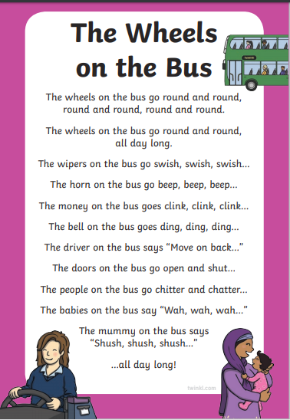

Sight words for Junior Infants
I | like | the | this | is | a | see | can | went | to
look | at | we | was | want | and | he | his | said | she
her | on | in | am | little | big | play | eat | me | my
if | of | here | going | are | it | has | they | but | with

Sight words for Senior Infants/ First Class

that | but | had | all | there | some | come | came | have
down | do | could | when | did | what | why | when | where
them | one | two | three | four | five | six | seven | eight
blue | green | red | black | white | orange | now | ask | very
don’t | your | from | up | not | will | yes | no | go
because | around | too | take | make | every | away | their | saw
brown | walk | or | before | again | never | today | try | myself
does | goes | always | once | upon | a | time | soon | find
those | use | say | found | live | together | thank | laugh | give
be | as | out | were | so | who | have | new | our
nine | ten | yellow | nice | an | over | buy | open | after
you | good | about | call | called

