New Class Novel  The Easter Rising, 1916, Molly’s Diary  Author: Patricia Murphy  Molly’s diary interweaves the real history of 1916 with an invented story. We call this genre or type of writing, historical fiction. | 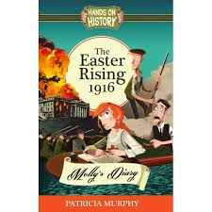
Ireland in 1916
From your reading of the novel and your research, try to answer these questions about life in Ireland in 1916:

1. | Dublin is the second city of which empire?
2 | What/where is the widest street in Europe?
3 | What does the big banner on Liberty Hall on Burgh Quay, in Dublin, say?
4 | What is Home Rule?
5 | Who is the leader of the Fianna Boy Scouts?
6 | Who is the Chief of Staff of the Irish Volunteers?
7 | What Does Francis Sheehy Skeffington believe? (This may be tricky if you don’t have the novel to hand.) See how much you can find out.

